MARKING KEY FOR MAP READING AND PHYSICAL GEOGRAPHY I 2026 NED
QUESTION ONE
1 a (i) Confluence (1mark)
(ii) 651396 (2marks)
b (i) Nanchinkha, Mtundu, Mbedza (1mark)
c (i) North west (1mark)
(ii) 180° + 78°
= 258° (3marks)
d (i) No (1mark)
ii. Because there is highland between them shown by contours which are close together. (2)
(iii) full boxes 1 (1)
Half boxes 9/2 = 4.5 (1)
Total 1+ 4.5 (1)
= 5.5 xkm² (1)
= 5.5 km²
= 6km² (to nearest km²) (1)
(iii) Cultivation along the dam
Dumping wastes in the dam (1)
e.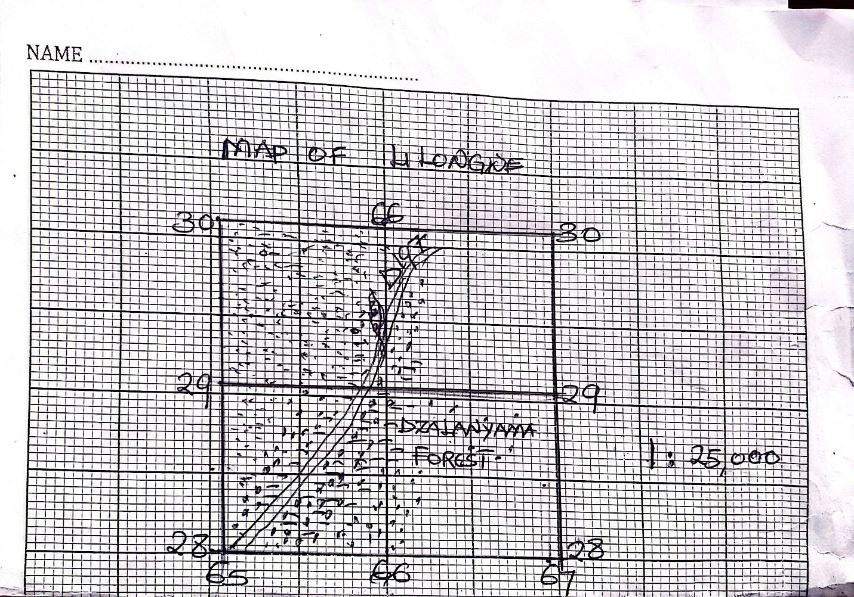
QUESTION TWO
2 a (i) A Nazca, B Philippine pacific plate (1)
(ii) Oceanic Plate (1mark)
(iii) Trenches
Volcanic mountains
Fold Mountains
Earthquakes. Any two for (2marks)
(iv) As plates moved away from each other, crack was formed. Magma erupted, cooled and solidified above water surface forming an island. (2marks)
b (i) Alps mountain
Himalayas (2marks)
(ii) - Can force warm moist air to rise, cool and condense resulting in precipitation of orographic rainfall
-Can cause temperature variation between different elevations
Fold Mountains can block air masses influencing regional climatic patterns (4marks)
C (i) It is formed when the less dense river water carrying large volume of fine materials flow
into denser sea water. (3marks)
(ii) Flooding
Pollution
Ecosystem collapse (2marks)
d. -damage to people’s property such as buildings and roads.
-Loss of lives for plans and animals. (4marks)
ii. – Uprising convectional currents.
- They bring fair weather. (2marks)
iii. – cirrus. Cirrocumulus. (1mark)
Question Three
3 a (i) Warm currents originates from tropics to the poles and cold currents originate from the
poles to the tropics. (2marks)
(ii) – Shipping. It eases movement of ships since ships are pushed by currents.
- Fishing. Meeting of warm and cold ocean currents leading to precipitation of minerals which allow growth of planktons which are food for fish.
- Warm currents provide warmth and precipitation to the adjacent land mass causing climate change. (2marks each)
b (i) A Continental shelf. (1mark)
B Ridge. (1mark)
(ii) It is formed when the edge of the continental slope gently down warps under the surrounding ocean waters (2 marks)
C (i) Have crystals (One mark each)
No layers
No fossils
(ii) Intrusive rocks formed below the surface and have large crystals (two marks each)
Extrusive rocks formed on the surface and have small crystals
(iii) Coal, Lignite, Peat (1mark)
d i
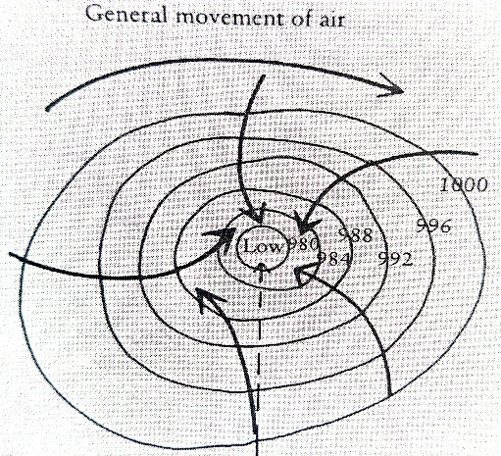 (2marks)
- The cyclone rotates clockwise in the southern hemisphere while the winds are deflected the left (anticlockwise) (2marks)
(ii) 1.Heat and moistures act as a source of energy for the cyclone (1mark)
2.It cause air to spin as cool air flows into low pressure centre (1mark)
e(i) Vegetation absorbs carbon dioxide from the atmosphere through
photosynthesis removal of it increases accumulation of carbon dioxide in the air leading
to air pollution (2marks)
ii . Insufficient funds
- Lack of cooperation among members
- Lack of public engagement and education (2marks)

Question Four
4a (i) Tropical desert climate (one mark)
(ii) Northern Hemisphere, temperatures are low in winter from January to March and
temperatures are harsh summer in May to July. (2marks)
(iii) Mali, Chad, Niger, Mauritania and Libya (2marks)
b (i) Unreliable rains
Temperatures are very high throughout the year
Commonly found in tropics of high pressure belt
High evaporation rate of temperature (4marks)
(ii) -High evaporation rate due to high temperatures
- Sandy soils cannot support agriculture
- Intense dusty winds which can cause sand and other objects to be tossed around- dangerous to driving, flying and walking (4marks)
C (i) It shift to the north during northern hemisphere summer and to the south during southern hemisphere summer (2 marks)
(ii) - Strong convectional activity.
- Violent thunderstorms
- Massive rain bearing cumulonimbus clouds with heavy, thunder and lightening.
Plate tectonics builds up mountain ranges and during geological movements cause position of land masses and water bodies change in relation to latitudes (2marks)
D i
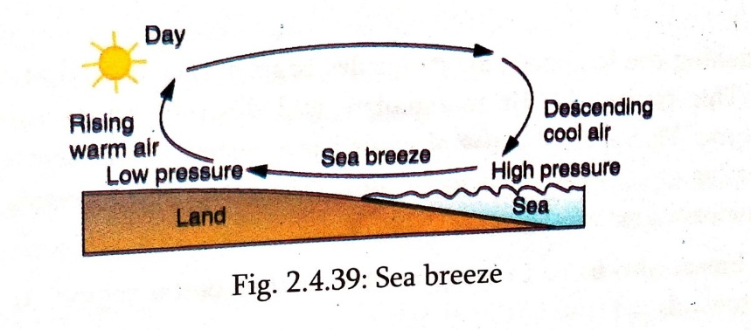(3marks)
- ii. During the day or summer, the land heats up faster than water in the sea.
- This will make air molecules above the land expand and occupy a large space causing low pressure (on land)
- At the same time, the sea heats up much slower than the land during the day. As a result, temperatures above water are lower than above land causing high pressure on the sea.
- This means air will move from the area of high pressure (sea) to the area of low pressure (land) creating a sea breeze. (3marks)
ii. - They all result from the rising moist air.
- They result from saturation of warm moist air when temperature is at dew point
- They all result from condensation of warm moist air (2marks)
Question five
5 a (i) What name is given to the feature labeled R and P
R: Block Mountain. (1mark)
P : Rift valley. (1mark)
ii. Name the type faults associated with process above.
– Reverse fault. (1mark)
iii. Explain the geographical force that is responsible for the development of the fault you have mentioned above. (2marks)
- Compression force. It is a force that squeezes an object causing it to shrink or deform.
- Two forces operate on an from opposite directions pushing the two side blocks close
together.
iv. Briefly explain how the feature marked R is formed.
- the crust is exposed to the compression force. Reverse faults develop. Side blocks
Thrust over the central block. The side blocks become Block Mountain. (4marks)
b.i. it is a U-shaped body of water formed when a wide meander from the main river is cut off to create a lake. This is usually due to deposition and erosion. (3marks)
ii. for fishing, water for domestic and industrial use, transportation (2marks)
c i.and ii.
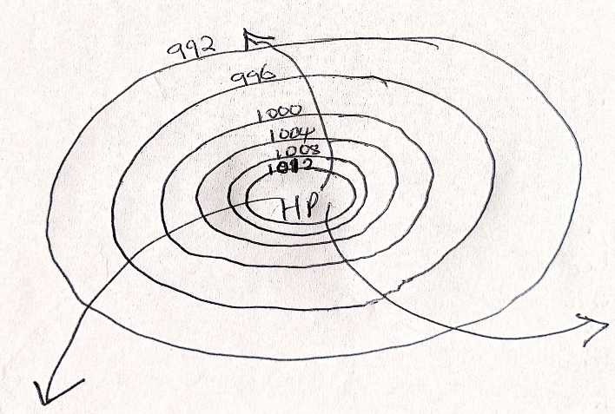 (3marks) and 1mark for arrow for direction of wind
(iii) Hamarttan (1mark)
d.i It is the force of air created by the weight of the atmosphere at a point on the earth’s surface. (1mark)
ii.
a). High temperatures along the equator causes air to expand which causes it to rise in convectional current and low pressure forms (2marks)
b) Low temperatures result in cold air that contracts and becomes dense causing high pressure.
(2 marks)
iii. - Prevailing winds blow for long period of time while local winds blow for a short time.
- Prevailing winds affect a large area while local winds affect small areas (2marks)
END OF MARKING KEY

